Laurier Centre for Sustainable Food Systems’ 2020–2021 Annual Report

What We Do
The Laurier Centre for Sustainable Food Systems (LCSFS) addresses the complex environmental, social, and economic challenges facing our food systems by creating:
- Collaborative research opportunities among food systems researchers and community partners
- Robust knowledge sharing networks that connect food systems actors at the local and international level
- Sustainable food systems change through community-driven research, knowledge mobilization, capacity building, and advocacy
- Experiential learning opportunities for students, research associates, practitioners, community members, and partners
- Resources and tools for community partners and food systems actors to support on-the-ground work in sustainable food systems

Our Vision
Our vision is a world where food systems are key to a more equitable, ecologically regenerative, and economically sustainable future in which all actors have the capacity to advance positive food systems transformation.

Our Mission
Our mission is to conduct and share community-driven research through local, national, and global networks to foster more sustainable food systems.

Our Research Approach
In our community-engaged research we work with diverse food systems actors to:
- Co-create knowledge about sustainable food system practices and solutions to community and place-based challenges
- Bring together food systems actors in dynamic global knowledge sharing networks to learn from each other and build community capacity to affect meaningful change at multiple scales

Snapshots, 2020–2021
- Continued building our connections with more than 50 partner institutions
- Coordinated 8 major multi-year projects, including 4 in the NWT
- Produced and released 7 episodes of Handpicked: Stories from the Field
- Created more than 20 academic publications and reports and hosted 6 online events
- Trained and supporter 13 highly qualified personnel through studentships and research assistantships
- Created the UNESCO Chair on Food, Biodiversity and Sustainability Studies with partners in more than 10 countries

Focus Areas, 2020–2021
In 2020–2021 the LCSFS focused on five key areas:
- Increasing UNESCO Chair on Food, Biodiversity and Sustainability Studies activities;
- Securing new external funding through grant writing;
- Supporting ongoing research;
- Cultivating new research partnerships; and
- Raising the LCSFS profile through strategic knowledge mobilization.

UNESCO Chair on Food, Biodiversity and Sustainability Studies
Jointly hosted by Wilfrid Laurier University and the Balsillie School of International Affairs, the UNESCO Chair on Food, Biodiversity and Sustainability Studies promotes research, communication, and education about the relationships among biodiversity, food, and sustainability. Dr. Blay-Palmer serves as the inaugural Chairholder.

Key Chair Activities
- Developed the UNESCO Chair FBSS Strategic Plan, Sustainable Food for a Resilient Future and set research and partnership priorities from 2020–2024;
- Building Back Better Post COVID-19 Task Force, led by Dr. Blay-Palmer, published a position paper and policy briefs on Biodiversity and Ecosystems, Sustainable Food Systems, and Green Infrastructure;
- UNESCO Chair webinar series focused on key chair themes including Biodiversity and Food Justice, and its first Spanish-language webinar focused on Biodiversity and Food Systems in Brazil and Mexico;
- Began development of a graduate certificate in Food, Biodiversity and Sustainability Studies at Laurier

Voicing Change: Co-Creating Knowledge and Capacity for Sustainable Food Systems
Voicing Change, led by Dr. Andrew Spring, is a new three-year SSHRC Insight grant announced in 2021.
The Project's goal is to build a healthier, more equitable, and socio-ecologically resilient future that is grounded in sustainable local food systems and centres Indigenous and traditional knowledge.
Voicing Change will connect community partners, researchers, and students in the Northwest Territories, Canada (led by Laurier); Migori County, Kenya (led by Rongo University); and the State of Paraná, Brazil (led by CEDErva and Embrapa Forestry).

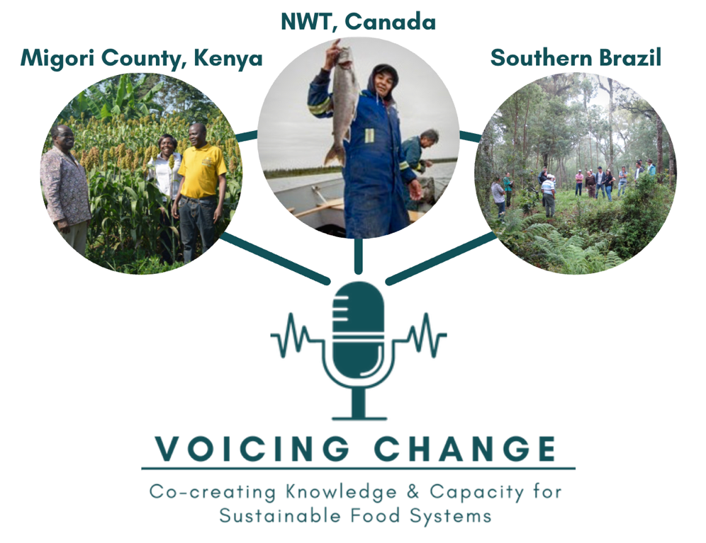

Northwest Territories
Dr. Andrew Spring, LCSFS Associate Director and lead researcher of the Northern Food Systems Research Group (NFSRG), works closely with community partners on food systems projects in several Indigenous communities in the NWT. Key community partners include: Ka’a’gee Tu First Nation, Sambaa K’e First Nation, Ecology North, and the Tsá Tué Biosphere Reserve, where he is an advisor. Key Laurier partners include faculty from the Cold Regions Research Centre (CRRC).

Key Projects
- Voicing Change: Co-creating Knowledge and Capacity for Sustainable Food Systems (New): 2021-2024
- Identifying Opportunities and Barriers for Local Food Infrastructure in Yellowknife, NWT (New): 2021
- Northern Agriculture Futures: Climate Change Preparedness in the North Program: 2019-2023
- Learning from and Enhancing Community Capacity for Climate Change and Food Security (C4FS) Action in the NWT: 2019-2024
- Climate Change Adaptation Planning in Ka’a’gee Tu and Sambaa K’e: 2019-2021

Project Updates

Food: Locally Embedded, Globally Engaged (FLEdGE)
FLEdGE focuses on community-driven research on sustainable food systems across seven national research nodes and three thematic international working groups. Led by Dr. Blay-Palmer (PI) and now in its final phase, FLEdGE is focused on strategic KMb efforts to increase overall engagement with the project findings and create audience-specific research outputs.
fledgeresesarch.ca

Urbal: Urban-Driven Innovations for Sustainable Food Systems
Urbal is an international partnership between CIRAD, EStà, and the LCSFS that is co-led by Dr. Blay-Palmer. The Urbal methodology was created for practitioners, funders, and policymakers to help improve decision-making capacity and was tested in 8 Urban Food Innovation Labs. In 2020-21, Urbal moved into its final phase, with researchers creating a modular publicly accessible toolkit and writing an edited academic volume.
urbalfood.org

City Region Food Systems (CRFS) Project
This partnership between the UN Food and Agriculture Organization (FAO), RUAF, and the LCSFS offers resources for practitioners assessing and building sustainable city region food systems. In 2020–21, Dr. Blay-Palmer co-led phase 2 of the project, which engaged directly with cities to increase climate resilience using food. CRFS also created a special series of papers from participant cities responding to COVID-19.
fao.org/in-action/food-for-cities-programme/toolkit

